Specific Focus | Task: Student Directions | Example
Step 1:  Logging On | - Turn on a Chromebook  - Do NOT log in  - Click “Apps” in the bottom left  - Select AIRSecureTest | 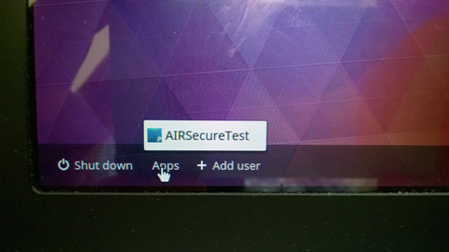
 | - Click the link that says “Click here to go to the Practice and Training Test Site” | 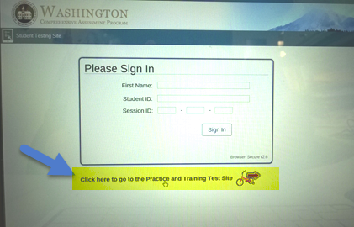
 | - Just click “Sign in” as a guest. | 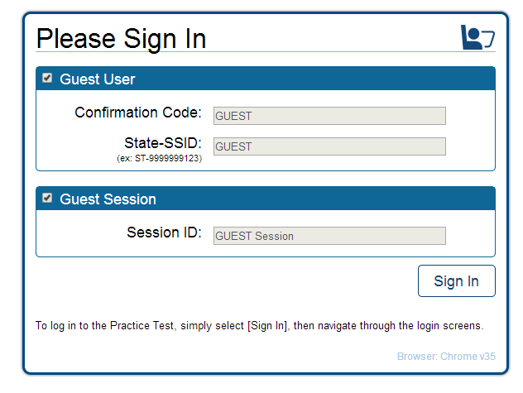
Step 2:  Sign in | - Choose your grade level.  - Click “Yes” to start. | 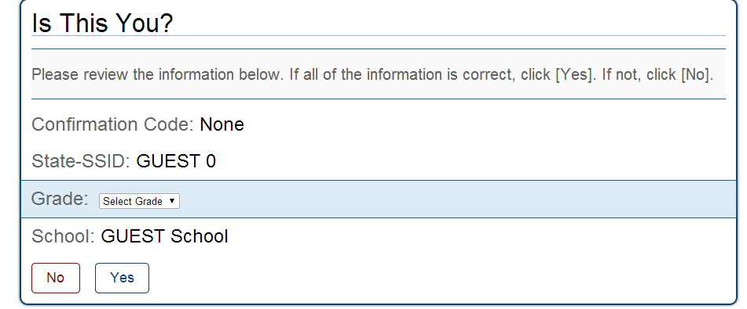
Step 3:  Test Choices | - Click Start Math Grades 6-8 Training Test.  - Continue sign in process and click the button to Begin Test Now.  - On the screen for Choose Settings, click Select.  - On the screen, Is This Your Test? scroll down and select, Yes, Start My Test. | 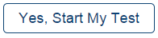  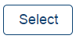    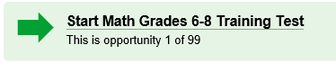
Step 4: Review Test Instructions & Help | - In this section of the test, it is helpful to scroll through the information about the tools you will encounter within the testing interface.  - Here you will find an overview of the student testing site, tools, and test rules.  - After review, click the Begin Test Now button. |   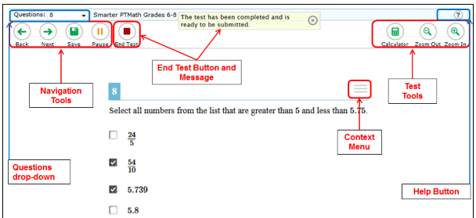
Step 5:  Tutorial | - In the SBAC Math & ELA assessments you will see the Tutorial as one of the choices when you click on the Context Menu.  - The Tutorial provides a video tutorial explaining how to answer that type of question. | 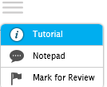

Step 6:  Notepad | - Each question on either the SBAC Math or ELA assessment has a Notepad tool found under the Context Menu.  - You can use the Notepad to save a note or comment about that question.  - To use the notepad, click on the Context Menu and select Notepad. This will bring up an area you can type in. Then select Save and Close to save your notes.  *The notepad is specific to the question you are completing and will only be available throughout that portion of the test. | 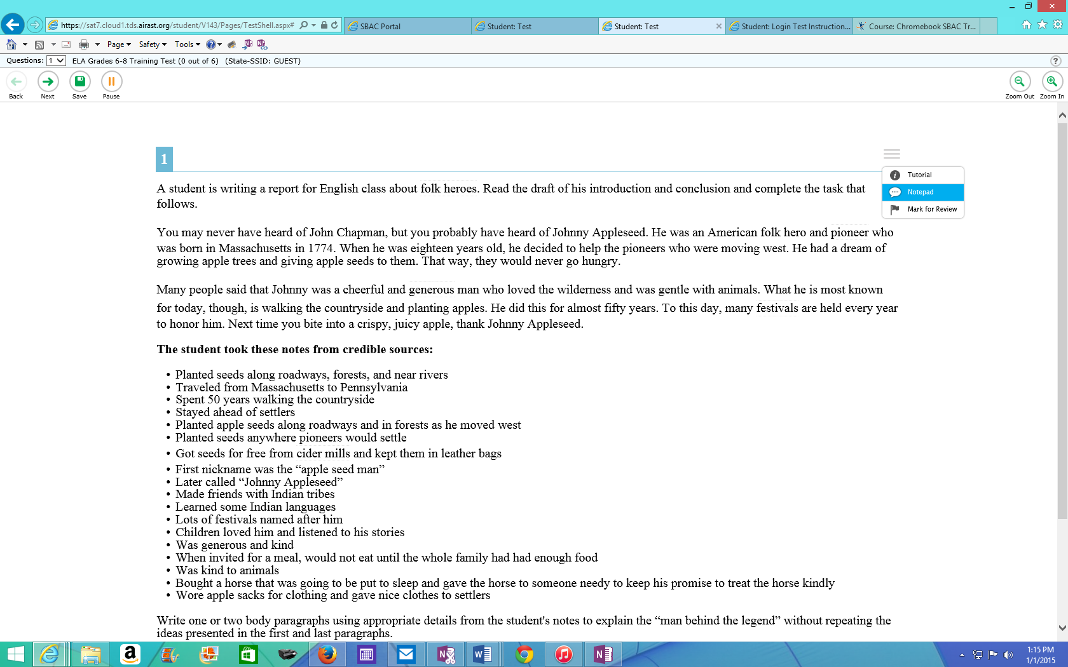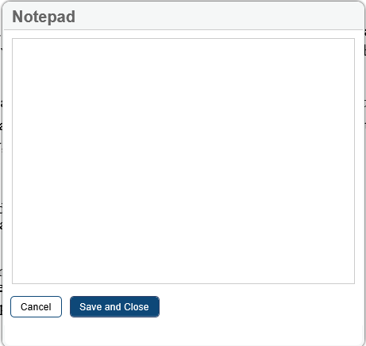
Step 7:  Flag (Mark for Review) | - Each question on either the SBAC Math or ELA assessment has a Flag (Mark for Review) tool found under the Context Menu.  - If you decide that you want to come back to the question prior to completing this segment of the test you can use the Flag (Mark for Review) tool.  - To use the Flag (Mark for Review) tool, click the Context Menu and then Mark for Review. This will change the look of the question number and show a white flap in the upper right corner.  - When you want to review an item either click the back button or the questions drop down to navigate to the previously marked question.  - You can clear the flag by clicking the Context Menu and Unmark Review Item.  *During testing you will be able to review these marked items and make changes to your answer if desired.  *If the test is paused for more than 20 minutes, the items marked will no longer be accessed for review. |   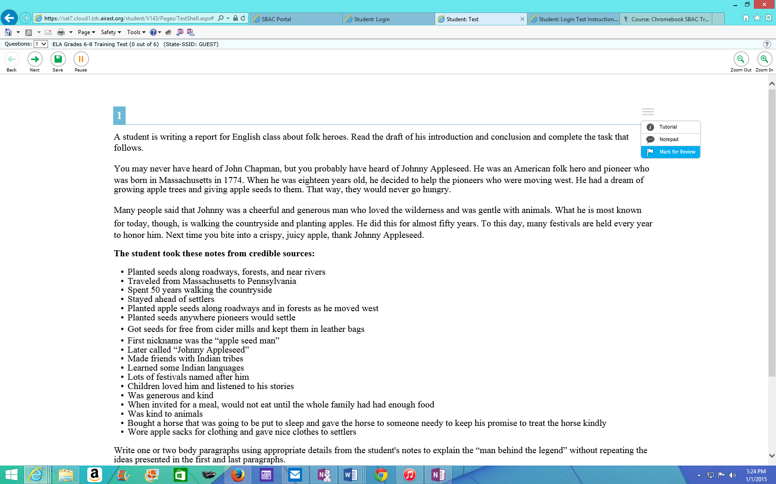
Step 8:  Reflection | Now that you have completed the practice using the notepad & flag tools, reflect and respond to the following questions on this document or open a new Google Document and SHARE it with your teacher. | - Describe two challenges or successes you encountered when using the notepad and/or flag tools on the practice test using a Chromebook.  - Did you know you can also use these tools on the SBAC ELA Assessment? Give an example of how you could use these tools on the SBAC Math assessment.
 | On a scale of 1-10 how you’re your comfort level with these tools?  8-10 I feel comfortable with the tools but I could redo this lesson for additional practice.  5-7 I am somewhat comfortable with these tools but could use additional practice.  0-4 I am still not comfortable with these tools and need to complete the practice again. | - If you gave yourself a rating of 8-10, what can you do to help other students achieve the same score?  - If you did not get give yourself a rating between 8-10, what do you plan to do to improve your score?

